Name: Melanie Holland
School and District: Fairforest Elementary School, Spartanburg School District 6
Grade: 2nd Grade
Unit Framework Title: Fairy Tales with Rapunzel
Genre: (What type/kind of reading/writing) Fairy Tales
Time frame: (Length of unit) 1 week

Read to Self:
Materials used: fairy tales from class library and online reading sites, including:
The Princess and the Pizza, Cinderella, Snow White and the Seven Dwarves, Rapunzel, Henny Penny, The Bremen-town Musicians, The Princess and the Pea, Little Red Riding Hood, Newfangled Fairy Tales
Mini-lessons: What is a fairy tale?
Anchor charts:
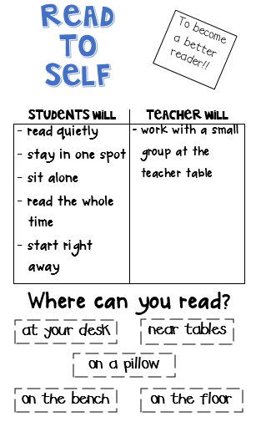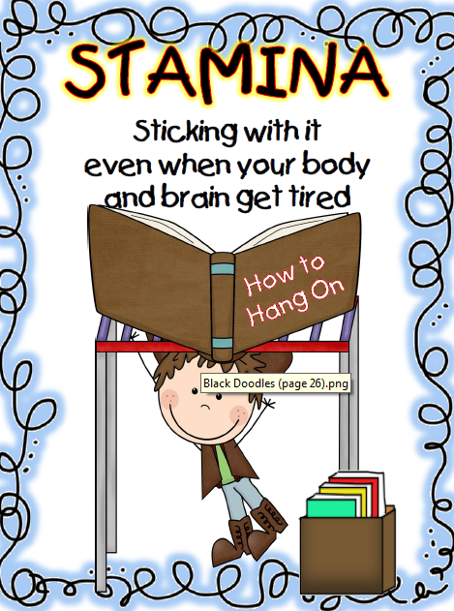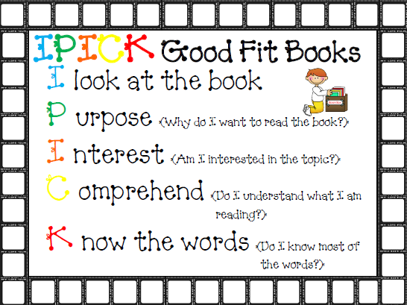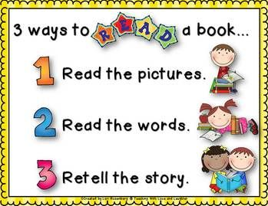
Assessment: AR tests, teacher observations, class check-in
Work on Writing:
Materials used: PowerPoint on elements of fairy tales, Thinking Maps, Write From The Beginning
Mini-lessons: Using mentor text ( Rapunzel ) to model writing
Anchor charts:
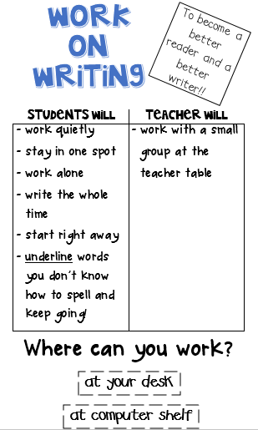
Assessment: WFTB rubric of student-created fairy tale
Read to Someone:
Materials used: fairy tales from class library and online reading sites, including:
The Princess and the Pizza, Cinderella, Snow White and the Seven Dwarves, Rapunzel, Henny Penny, The Bremen-town Musicians, The Princess and the Pea, Little Red Riding Hood, Newfangled Fairy Tales
Mini-lessons:
- Comparing story versions – Students will read two versions of the same fairy tale to compare and contrast with partner.
Anchor charts:
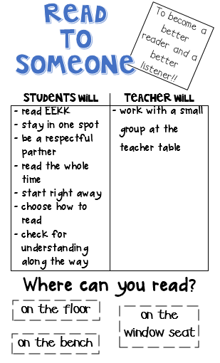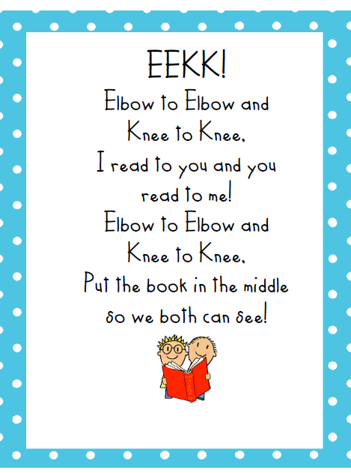
Assessment: Venn Diagrams will be assessed for accuracy.
Listen to Reading:
Materials used: www.biguniverse.com, headphones, response sheets
Mini-lessons: Review of story elements
Anchor charts:
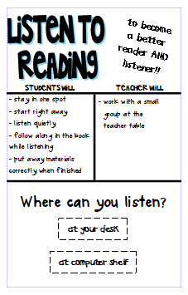
Assessment: teacher observations for tracking and quizzes on fairy tales
Word Work:
Materials used: www.spellingcity.com, tablets, laptops, magnet letters, dry erase boards, dry erase markers
Mini-lessons:
- What are homophones?
Anchor charts:
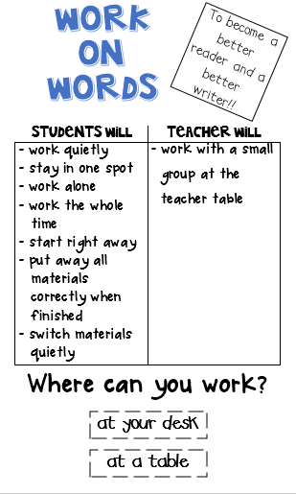
Assessment: Spelling test
Science/Inquiry:
Materials used: dry spaghetti, masking tape, string, scissors, marshmallows (regular and mini), lab sheets, pencils
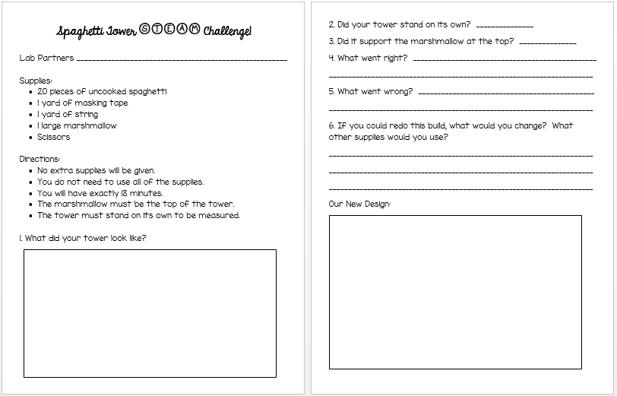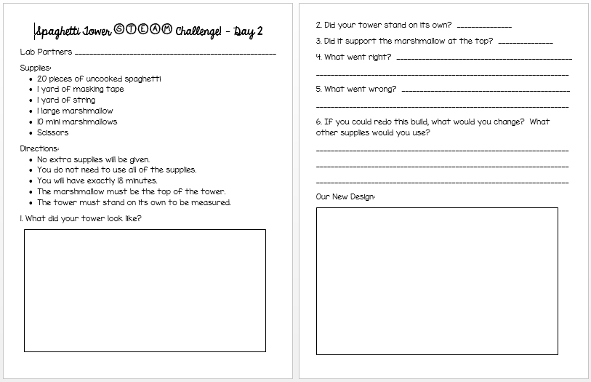
Mini-lessons:
- Review of teamwork expectations
STEAM Activities: Day 1 - Given a set of materials, students will construct a tower for Rapunzel (regular-sized marshmallow) that can stand on its own and support Rapunzel. Students will work in teams of two to plan, create, and reflect on towers. During reflection, students will discuss and write about what went right, what went wrong, and what could be changed.
Day 2 – Students will be given the same materials, time frame, and goal as Day 1, as well as additional materials (mini-marshmallows). Student groups will design and create a different structure from Day 1’s design. Again, students will work in teams of two to plan, create, and reflect on towers. During reflection, students will discuss and write about what went right, what went wrong, and what could be changed.
Assessment: Teacher observation during activity; lab sheets checked for accuracy
SC College- and Career-Ready standards addressed in unit:
Reading Literary Texts Standards:
7.1 Retell the sequence of major events using key details; determine the theme in text heard or read.
7.2 Read or listen closely to compare and contrast multiple versions of the same story; compare and contrast texts in author and genre studies.
12.1 Describe the overall structure of a narrative including how the beginning introduces and the ending concludes the action.
13.1 Engage in whole group and small group reading with purpose and understanding.
13.2 Read independently for sustained periods of time to build stamina.
13.3 Read and respond according to task and purpose to become self-directed, critical readers and thinkers.
Writing Standards:
3.2 Plan, revise, and edit, focusing on a topic while building on personal ideas and the ideas of others to strengthen writing.
Inquiry-Based Standards:
  - Ask self-generated questions that lead to group conversations, explorations, and investigations.
4.1 Interpret relationships and patterns discovered during the inquiry process.
4.2 Use appropriate tools to communicate findings and/or take informed action.
4.3 Reflect on findings and pose new questions for further inquiry.
5.1 Acknowledge and value individual and collective thinking.

