Attention, FES Students:
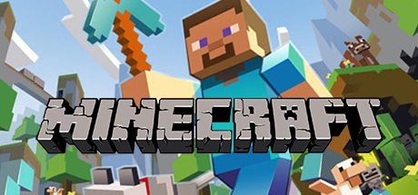

is coming!

Parents and Students,
We are very excited to let you know about a new after-school opportunity: Minecraft Club! Our school is now using MinecraftEDU for classroom instruction and extracurricular activities. We all know how much fun it is to play Minecraft, but there’s a lot to learn from this game as well: problem-solving, teamwork, literacy skills, and science concepts…just to name a few!
Starting NEXT TUESDAY, NOVEMBER 10, Minecraft Club will meet on Tuesday and Wednesday afternoons from 3:00-4:00. Your child will be assigned a day based on his/her level of experience with the game.
Space is limited, so please complete and return this form to Mrs. Blackwelder as soon as possible!

Student’s Name ____________________________________________________________
Grade ______________ Teacher ______________________________________
How much do you know about Minecraft? Circle the best choice. It’s OK if you have never played!
I’ve never played. I know a little. I play regularly. I’m an expert.
Parents: Will you be able to pick your child up at 4:00 on his or her assigned day? _______________
Does your child already attend our after-school program? ______________________

Parent Signature _____________________________________________________________________________

