**Matter Unit Plans**

**Day One:**

**Objective:** Students will be able to determine the three state of matter.

**Lesson:** At the beginning of the lesson, students will formulate questions about matter on a class Padlet. Students will view the BrainPop video on Matter from ItsLearning and collect relevant information about the three states of matter. They will organize this information in a chart of their choice in their Science journal. Students will then discuss their information within their table groups.

**Standards:**

* 1.1 Formulate questions to focus thinking on an idea to narrow and direct further inquiry.
* 3.1 Develop a plan of actions for collecting relevant information from primary and secondary sources.
* 3.2 Organize and categorize important information; collaborate to validate or revise thinking, report relevant findings.
* 5.1 Acknowledge and value individual and collective thinking.
* 5.2 Employ past learning to monitor and assess current learning to guide inquiry.

**Day Two:**

**Objective:** Students will be able to classify different materials into the three states of matter based on their properties.

**Lesson:** Teacher will review the three states of matter with students. Then students will complete an inquiry activity on classifying materials into the states. They will look at the following materials: toothpaste, rice, colored liquid, and shaving cream and determine what state of matter they are based on their properties. Students will have to provide justification for their classification.

**Standards:**

* 2.1 Explore topics of interest to formulate logical questions; build knowledge; generate possible explanations; consider alternative views.
* 5.1 Acknowledge and value individual and collective thinking.
* 5.2 Employ past learning to monitor and assess current learning to guide inquiry.

**Day Three:**

**Objective:** Students will be able to describe how matter changes once heat is added.

**Lesson:** The teacher will bring in three different items for the students to observe. (candles, chocolate, and ice) Students will make observations and draw conclusions on how those objects can change into different states of matter by forming their own opinion without direct instruction. Students will then develop a plan to conduct an experiment on how to change the state of matter of the object. In this plan they will include a list of their materials needed. They will then share their plans with other students in the class.

**Standards:**

* 3.2 Organize and categorize important information; collaborate to validate or revise thinking, report relevant findings.
* 4.1 Draw logical conclusions from relationships and patterns discovered during the inquiry process.
* 4.2 Reflect on findings to build deeper understanding and determine next steps.

**Day Four:**

**Objective:** Students will be able to describe how matter changes once heat is added.

**Lesson:** Students will then conduct their experiments and make observations based on their results. Discuss the results of their experiments and note commonalties.

**Standards:**

* 4.2 Reflect on findings to build deeper understanding and determine next steps.
* 4.3 Determine appropriate tools and develop plan to communicate findings and/or take informed action.

**Day Five:**

**Objective:** Students will be able to describe how matter changes once heat is removed.

**Lesson:** The teacher will bring in three different items for the students to observe. (water, oil, melted chocolate) Students will make observations and draw conclusions on how those objects can change into different states of matter by forming their own opinion without direct instruction. Students will have access to countertops in the room, refrigerator, freezer. Students will then develop a plan to conduct an experiment on how to change the state of matter of the object. In this plan they will include a list of their materials needed. They will then share their plans with other students in the class. (May give students the option of attempting to change the state of two of the substances and then comparing the results.)

**Standards:**

* 3.2 Organize and categorize important information; collaborate to validate or revise thinking, report relevant findings.
* 4.1 Draw logical conclusions from relationships and patterns discovered during the inquiry process.
* 4.2 Reflect on findings to build deeper understanding and determine next steps.

**Day Six:**

**Objective:** Students will be able to describe how matter changes once heat is removed.

**Lesson:** Students will then conduct their experiments and make observations based on their results. Discuss the results of their experiments and note commonalties. Here it will be important to note the differences in the placement of the substances (counter, refrigerator, freezer) and how that impacted the change. The students may also notice variations in how the three different substances changed when heat was removed. Students may be encouraged to take a temperature reading of the location they are using to include in their data.

**Standards:**

* 4.2 Reflect on findings to build deeper understanding and determine next steps.
* 4.3 Determine appropriate tools and develop plan to communicate findings and/or take informed action.

**Day Seven**:

**Objective:** Students will formulate questions related to the experiments and complete research on Blendspace to answer these questions. They will write a reflection about the results they find.

**Lesson:** Students will review what they found from the data they collected in their experiments. They will then use the Blendspace link to answer any other questions they formulated. Students will take notes in their science notebooks. Then after collecting the information, they will write a reflection on what they found.

<https://www.tes.com/lessons/Uip15L_K-RtgWA/states-of-matter>

**Standards:**

* 2.1 Explore topics of interest to formulate logical questions; build knowledge; generate possible explanations; consider alternative views.
* 4.2 Reflect on findings to build deeper understanding and determine next steps
* 4.1 Draw logical conclusions from relationships and patterns discovered during the inquiry process.

**Day Eight:**

**Objective:** Students will be able to explain how heat changes occur in nature.

**Lesson:** Review the changes to matter that occur when heat is added. (Boiling, Melting, and Evaporation) Then, pass out the article, *Polar Action Guide*. (<https://www.nrdc.org/globalwarming/polaraction.pdf>) Read the article together and discuss what change is occurring. Discuss how this is effecting the animal life and what state of matter is changing. Students will annotate their text as they discover these answers. Then give students the article, *The Water Cycle*, (<http://www.kidzone.ws/water/>) Students will work in partners to discover what change is taking place. Have them discuss as a class the changes they observed in the article. They will then complete a quick write on how adding heat effects matter. These will be graded on a rubric.

**Standards:**

* 2.1 Explore topics of interest to formulate logical questions; build knowledge; generate possible explanations; consider alternative views.
* 3.2 Organize and categorize important information; collaborate to validate or revise thinking, report relevant findings.

Name \_\_\_\_\_\_\_\_\_\_\_\_\_\_\_\_\_\_\_\_\_\_\_\_\_\_\_\_\_\_\_\_\_\_\_\_\_\_\_\_\_\_\_\_\_\_ Date\_\_\_\_\_\_\_\_\_\_\_\_\_\_\_

**Heat and Changes in Matter (3-4)**

**Summative Assessment**

1. You are observing some matter that has mass, a definite volume, and takes the shape of its container. Classify it as one of the following: (3-4.1; 3-1.1)

1. gas
2. solid
3. water
4. liquid

2. You are observing some matter that has mass and a definite size and shape. Classify it as one of the following: (3-4.1; 3-1.1)

F. gas

G. solid

H. water

I. liquid

3. If you are using a meter tape to find the volume of some matter, what form of matter are you

most likely measuring? (3-4.1; 3-1.5)

A. gas

B. solid

C. water

D. liquid

4. If you are using a graduated syringe to find the volume of some matter, what form of matter are you most likely measuring? (3-4.1; 3-1.5)

F. liquid or gas

G. liquid or solid

H. solid or gas

I. only solid

5. Which of these describes a gas? (3-4.1)

A. a definite size and shape

B. a definite volume

C. a definite color and shape

D. no definite shape or volume

6. What is true of all matter? (3-4.1)

F. takes up space and has mass

G. has a definite shape and volume

H. takes the shape of its container

I. does not take up space

7. Which describes how much matter in an object? (3-4.1)

A. height

B. length

C. mass

D. volume

9. Which describes the amount of space taken up by an object? (3-4.1)

A. length

B. mass

C. temperature

D. volume

14. During freezing, a liquid cools to form which state of matter? (3-4.2)

F. a solid

G. a liquid

H. a gas

I. no change

15. A puddle of water gets smaller as it is warmed by the sun. Explain why this happens. (3-4.2)

A. condensation

B. evaporation

C. melting

D. freezing

16. Which process occurs when a gas is cooled enough to form a liquid? (3-4.2)

F. boiling

G. condensation

H. evaporation

I. freezing

17. Identify the example of freezing. (3-4.2)

A. An icicle forms on a really cold day.

B. A puddle of water gets smaller as it is warmed by the sun.

C. An ice cube is left on a counter and changes to liquid water.

D. A bathroom mirror is “foggy” after someone takes a hot shower.

Use the picture to answer question 18:

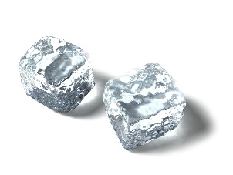 MCDD01086_0000[1] 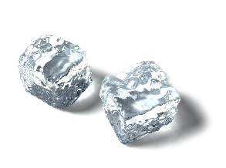

ICE WATER ICE

18. Which sequence of temperatures occurred to make this happen? (3-4.2; 3-1.2)

F. cold, warm, hot

G. warm, cold, cold

H. cold, cold, warm

I. cold, warm, cold

23. At what temperature does water freeze? (3-4.2)

A. 0˚ C / 32˚ F

B. 1˚ C / 33˚ F

C. 32˚ C / 0˚ F

D. 100˚ C / 212˚ F

24. Which of these is the boiling point of water? (3-4.2)

F. 100˚ C / 200˚ F

G. 100˚ C / 212˚ F

H. 110˚ C / 212˚ F

I. 212˚ C / 100˚ F

25. Which picture is an example of heat being produced by electricity? (3-4.4)

A. B. C. D.

MCj02979630000[1] MCj02925940000[1] MCBD08482_0000[1] j0322478

rubbing hands light bulb burning logs candle

26. Which picture shows a source of heat? (3-4.4)

F. G. H. I.

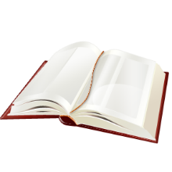 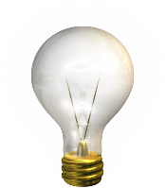 MCDD01086_0000[1] 

book light bulb puddle tree

Use this graph to answer questions 27-29:

**The Temperature of a Pot of Water**

Time in Minutes

Temperature in degrees Fahrenheit

5 10 15 20 25

220

200

180

160

140

120

100

27. What might be happening to this pot of water? (3-4.2; 3-1.6)

A. it is being heated on the stove

B. it has been placed in the freezer

C. it is sitting out on the counter

D. it has been placed in the sunshine

28. What change is occurring in this pot of water? (3-4.2; 3-1.6)

F. it is freezing

G. it is boiling

H. it is staying the same

I. it is cooling down

29. Which of these statements is most likely true? (3-4.2; 3-1.6)

A. This water is going from solid to liquid.

B. Some of this water has changed to a gas.

C. More of this water has turned into a liquid.

D. Some of this water has changed into a solid.

30. Use this thermometer to measure the temperature: (3-4.2; 3-1.5)

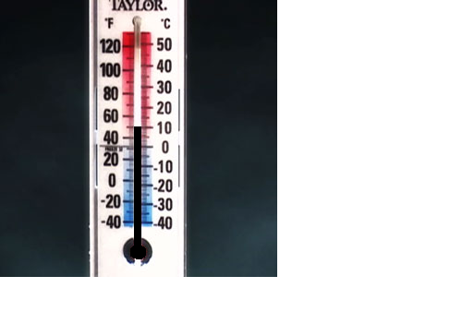

F. 40˚ F / 10˚ C

G. 45˚ F / 10˚ C

H. 50˚ F / 10˚ C

I. 50˚ F / 20˚ C